(OS : Ubuntu 14.04)

Step 1 : Install JAVA

# add-apt-repository ppa:webupd8team/java

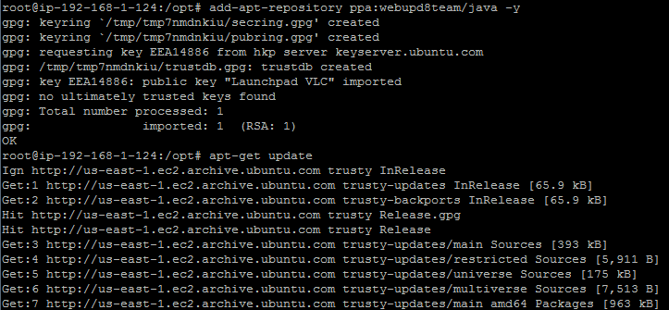

Step 1a :

# apt-get update

Step 1b :

Install java 8

# apt --assume-yes install oracle-java8-installer

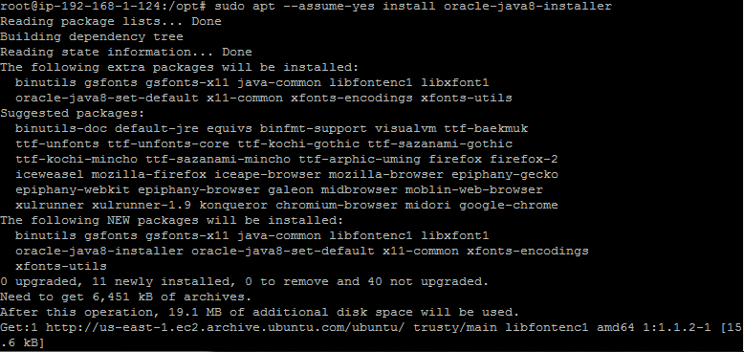

Check java is running

# java -version

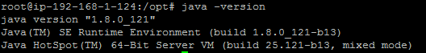

Step 2 : Download latest Nexus form the Sonatype nexus site

# wget <https://sonatype-download.global.ssl.fastly.net/nexus/oss/nexus-2.14.3-02-bundle.tar.gz>

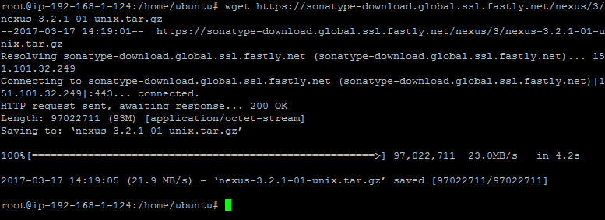

Step 2b : extract the contents and copy them to the **/opt** path.

# cp nexus-2.14.3-02-bundle.tar.gz /opt/

# cd /opt/

# tar -xvf nexus-2.14.3-02-bundle.tar.gz

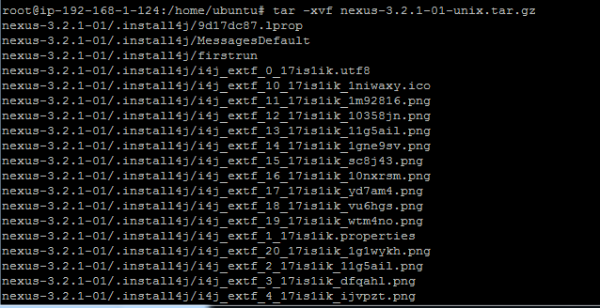

Step 2c : Create a new user **nexus** by command

# sudo adduser --no-create-home --disabled-login --disabled-password nexus

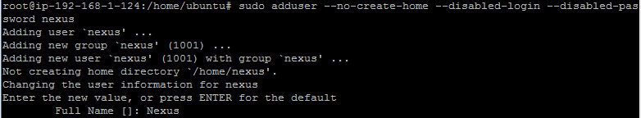

Create the password for the newly created user **nexus** by issuing following command

# sudo passwd nexus

root1234



Step 3: Edit the nexus configuration file

Next we need to edit the **nexus** file in directory **/opt/**nexus-3.2.1-01**/bin**. Here we will change the properties like which user will be used to run the application and path of the Sonatype Nexus OSS installation. Two of the properties will be modified here RUN\_AS\_USER=nexus & NEXUS\_HOME="/opt/nexus-3.2.1-01/"

# vim /opt/nexus-2.14.3-02-bundle/bin/nexus

RUN\_AS\_USER=nexus

NEXUS\_HOME="/opt/nexus-2.14.3-02-bundle/"

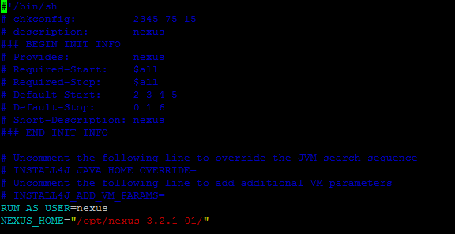

Step 3b:make the above file executable  
# chmod a+x /opt/nexus-2.14.3-02-bundle/bin/nexus

Next change ownership of the extracted nexus oss folder recursively to **nexus** user and **nexus** group by command

# chown -R nexus:nexus /opt/nexus-2.14.3-02-bundle/

Step 3c: Now you can start the nexus oss

# cd /opt/nexus-2.14.3-02-bundle/bin

# ./nexus start

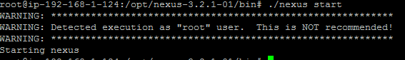

Step 4 : Type the url[http://your\_ip:8081](file:///C:\Users\Ahmad\Desktop\ http:\your_ip:8081)/nexus in browser & verify that application is live

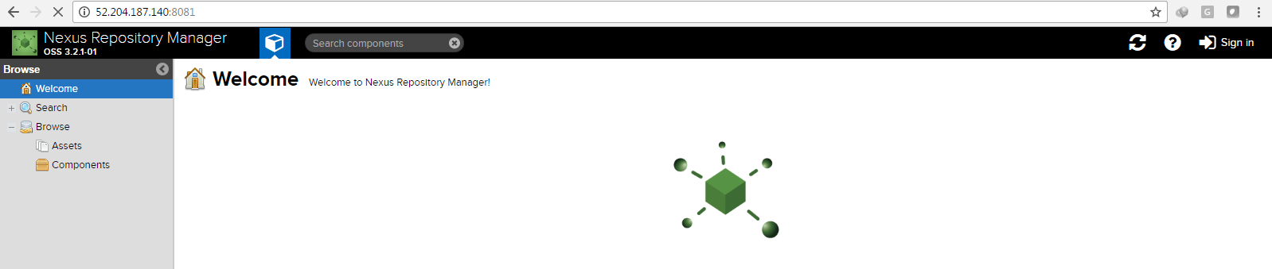

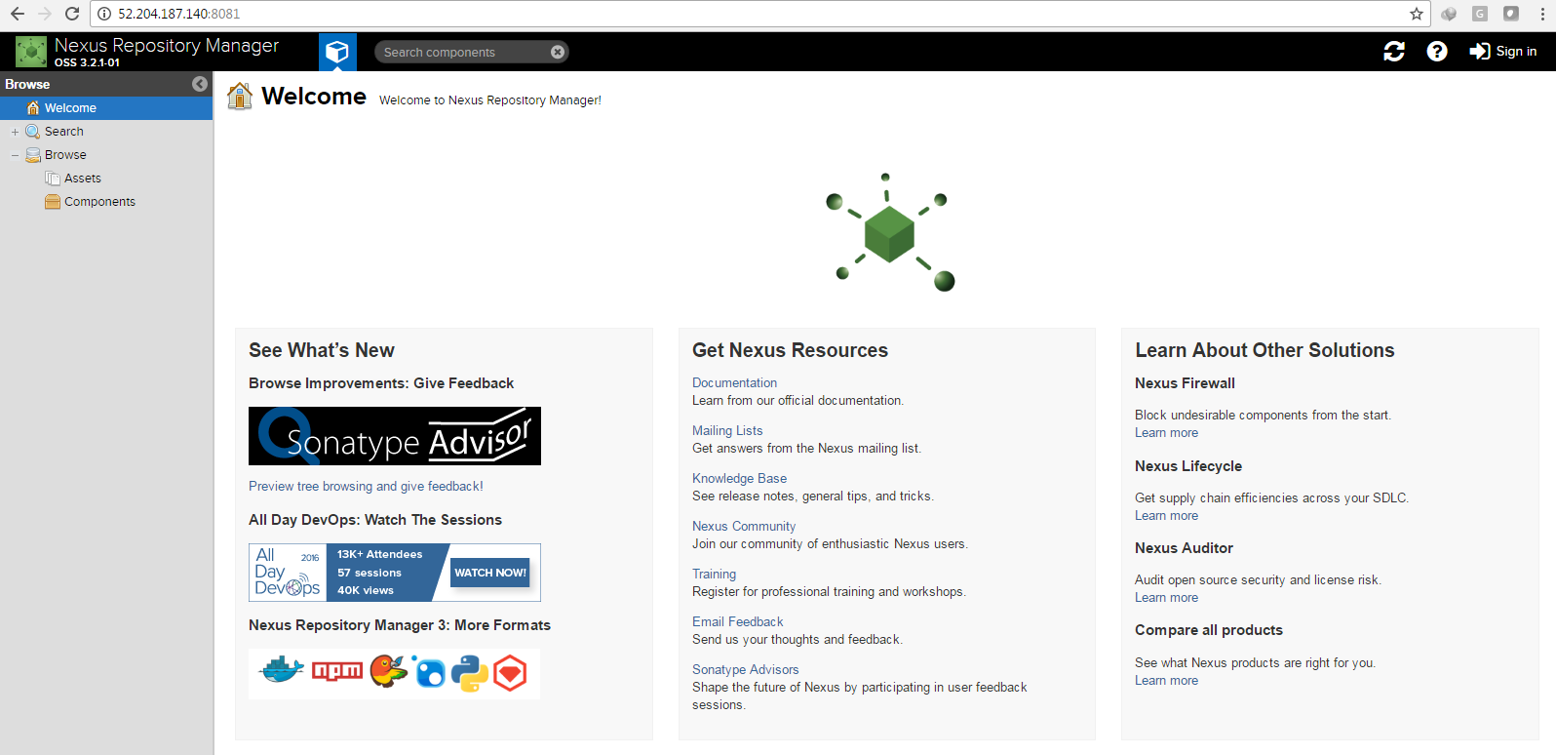

Step 4b: Login

**Username** **admin**

**Password** **admin123**

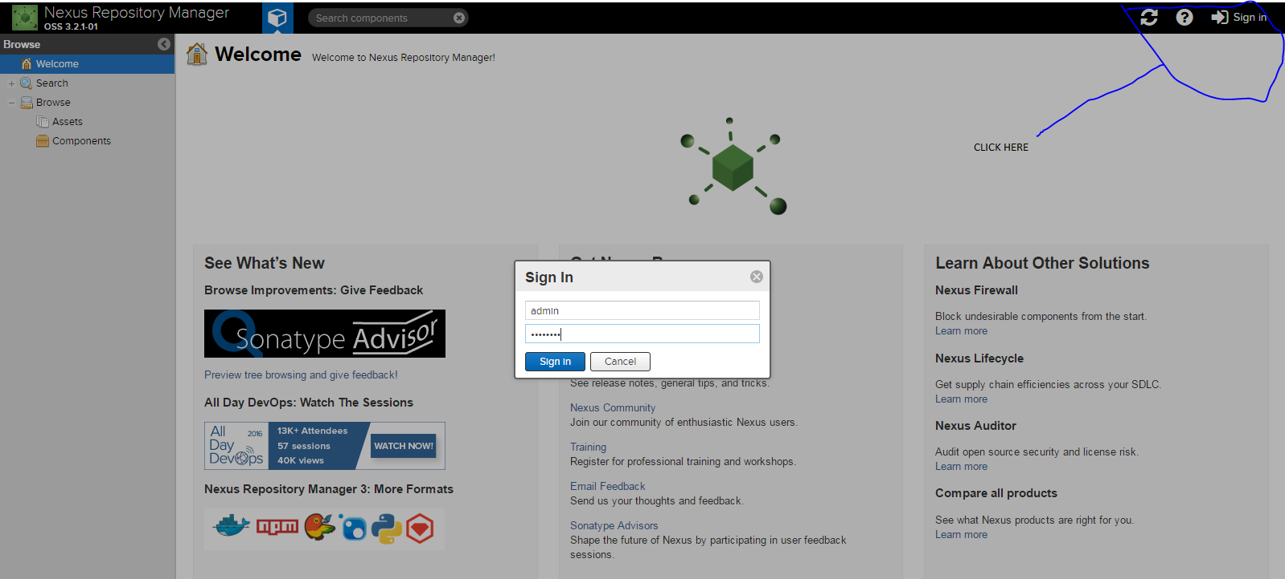

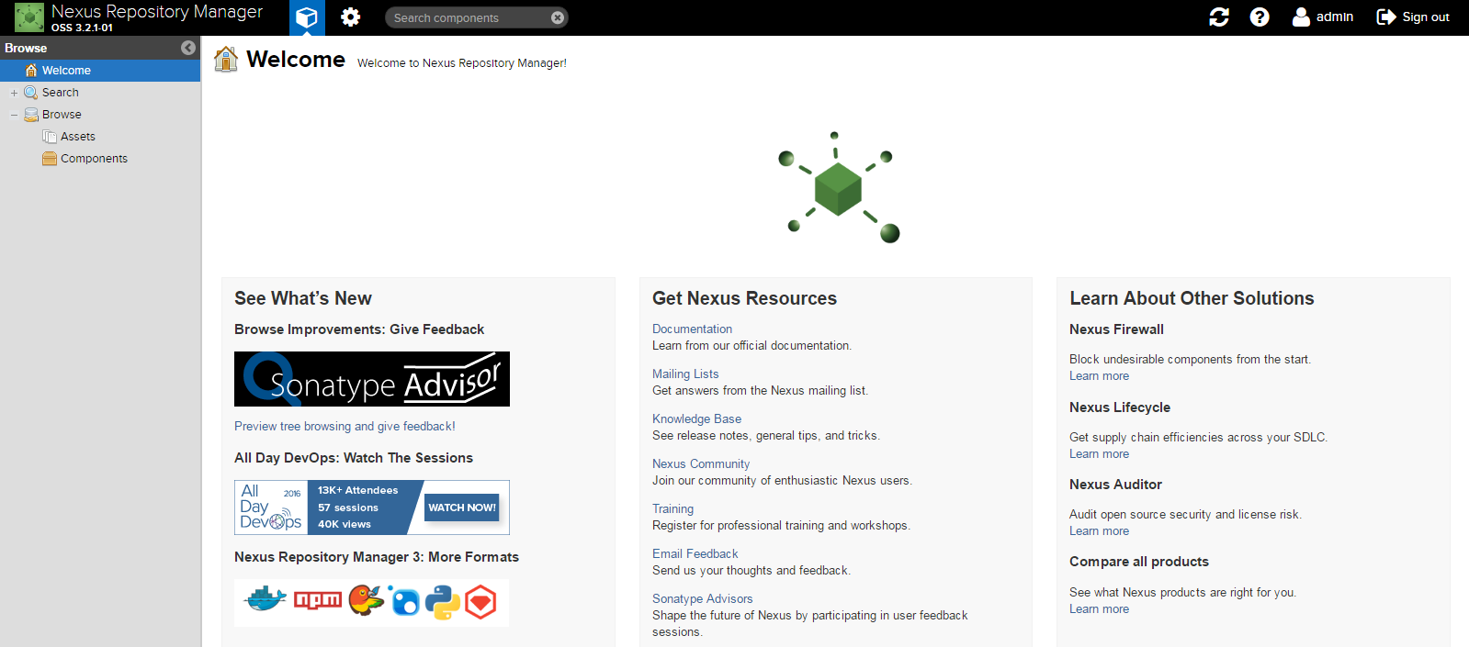

Status information regarding to this application can be checked as well. Below are some useful commands which can prove helpful  
# ./nexus start  
# ./nexus stop  
# ./nexus status  
# ./nexus console

To make life further easier, nexus binary can be added to path as well  
# sudo gedit .bashrc

export NEXUS\_HOME=/opt/nexus-2.11.4-01-bundle/nexus-2.11.4-01  
export NEXUS=$NEXUS\_HOME/bin  
export PATH=$PATH:$NEXUS

Congratulations Nexus OSS installation is complete.